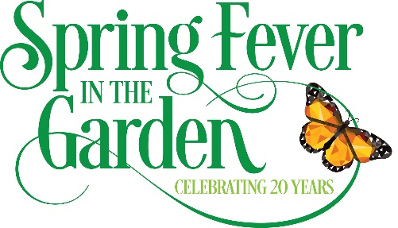
Sponsor Form
20th annual Spring Fever in the Garden
April 2 & 3, 2022

Please complete the form below and send check by March 31, 2022 payable to
Bloom and Grow Garden Society
c/o Julie Teal
633 Autumn Oaks Loop
Winter Garden, FL 34787
Click or tap here to enter text.
Organization or company name:
Official name for listing in media advertising & on website (attach business card)
Click or tap here to enter text.
Contact name & title:
Click or tap here to enter text.
Mailing address:
Click or tap here to enter text.
Email address of contact:
Click or tap here to enter text.
Click or tap here to enter text.
Contact’s numbers: Office Cell
Click or tap here to enter text.
Fax

Contribution:
PRESENTING SPONSOR: HEALTHY WEST ORANGE
Click or tap here to enter text.
Click or tap here to enter text.
Click or tap here to enter text.
Citrus $15,000 Pine $10,000 Cypress $7,500
Click or tap here to enter text.
Click or tap here to enter text.
Click or tap here to enter text.
Oak $5,000 Palm $3,000 Maple $1,000

Your company logo must be sent electronically by March 31, 2022, to joiamia@aol.com
Specs: Please send your Full Color logo in one of these formants: Tif, vector art, Eps, or jpgs; 300 dpi
Copy to: lindacb47@gmail.com , and gretchenboyd@aol.com
Click or tap here to enter text.
Bloom & Grow Contact:
Bloom and Grow is designated 501 (c)(3); Registration #: CH23240
A copy of the official registration and financial information may be obtained from the division of consumer services by
calling toll-free within the state. Registration does not imply endorsement, approval or recommendation by the state.1-800-435-7352

